**Exercise**

1. What is the size of MBR and what does it contains.

A master boot record is a kind of [boot sector](https://www.lifewire.com/what-is-a-boot-sector-2625815) stored on a [hard disk drive](https://www.lifewire.com/what-is-a-hard-disk-drive-2618152) or other storage device that contains the necessary computer code to start the [boot](https://www.lifewire.com/what-does-booting-mean-2625799) process.

The MBR is created when a hard drive is [partitioned](https://www.lifewire.com/what-is-a-partition-2625958), but it's not located *within* a partition. This means non-partitioned storage mediums, like floppy disks, don't contain a master boot record.

The master boot record is located on the first [sector](https://www.lifewire.com/what-is-a-sector-2626003) of a disk. The specific address on the disk is Cylinder: 0, Head: 0, Sector: 1.

The MBR consists of 512 or more [bytes](https://en.wikipedia.org/wiki/Byte) located in the first [sector](https://en.wikipedia.org/wiki/Disk_sector) of the drive.

This 512-byte space then is split up into two smaller sections. The first 446 bytes of the MBR contain the boot code—code like the first stage of GRUB that allows you to load an operating system. The final 66 bytes contain a 64-byte partition table and a 2-byte signature at the very end.

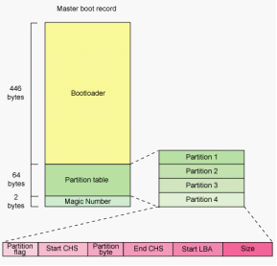

1. In which file you can write commands which you want to run whenever Linux system starts/restarts?

W/lib/systemd/system/rc.local.servicee can use ‘rc.local’ file located in ‘/etc/’ to execute our scripts and commands at startup. We will make an entry to execute the script in the file & every time when our system starts, the script will be executed.

1. Restart cron service.

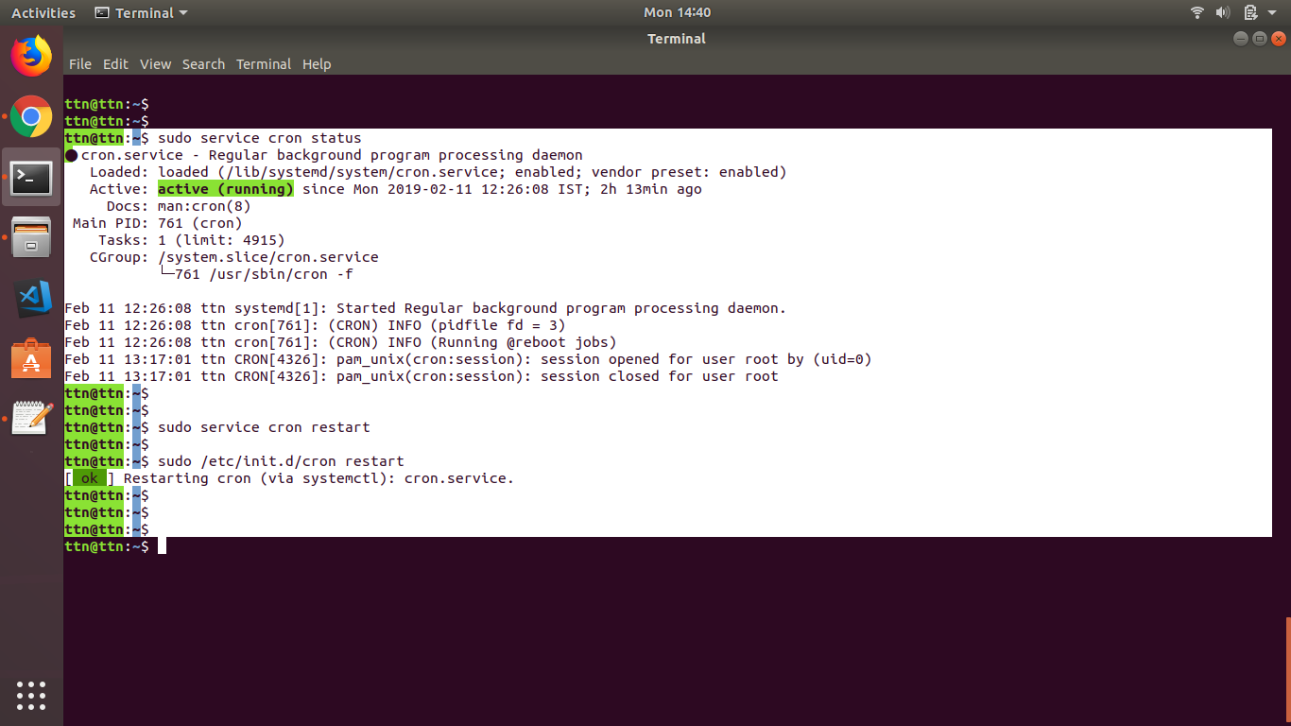

1. Create an ext4 filesystem

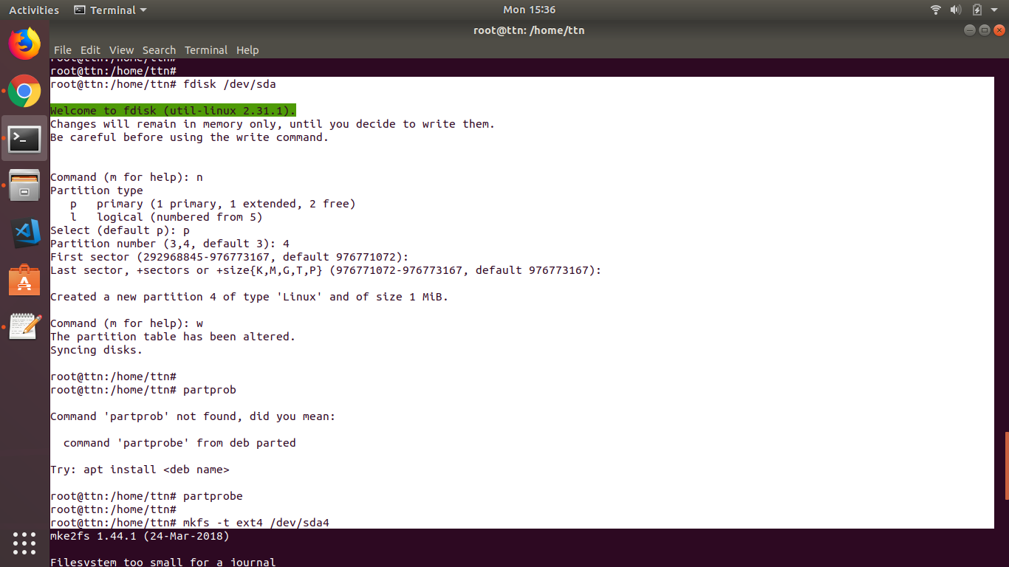

1. Mount the created filesystem on /partition directory.

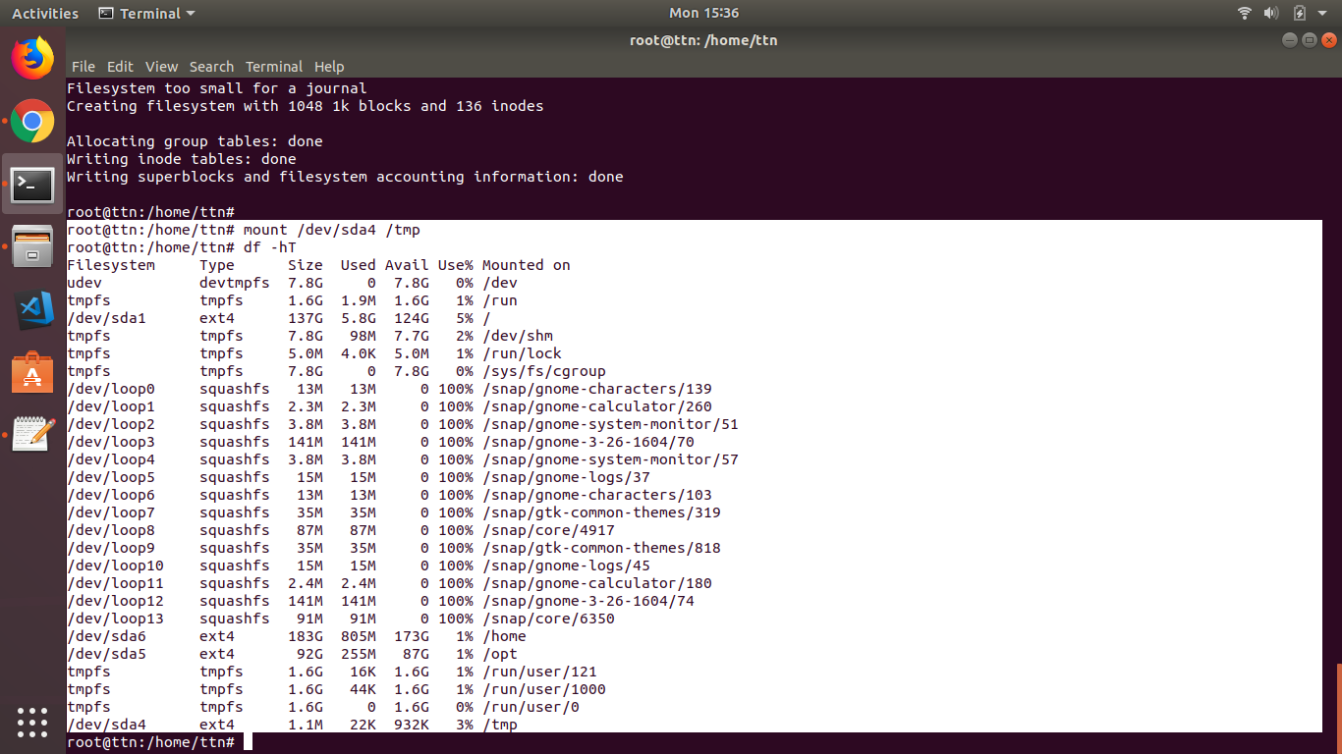

1. Create a user and add it to one secondary group.

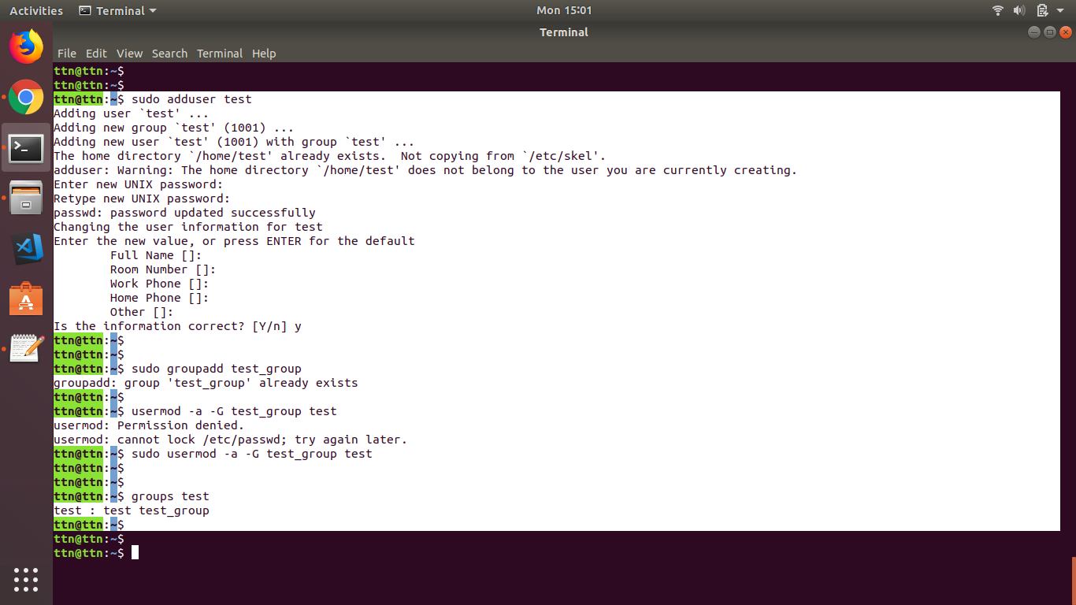

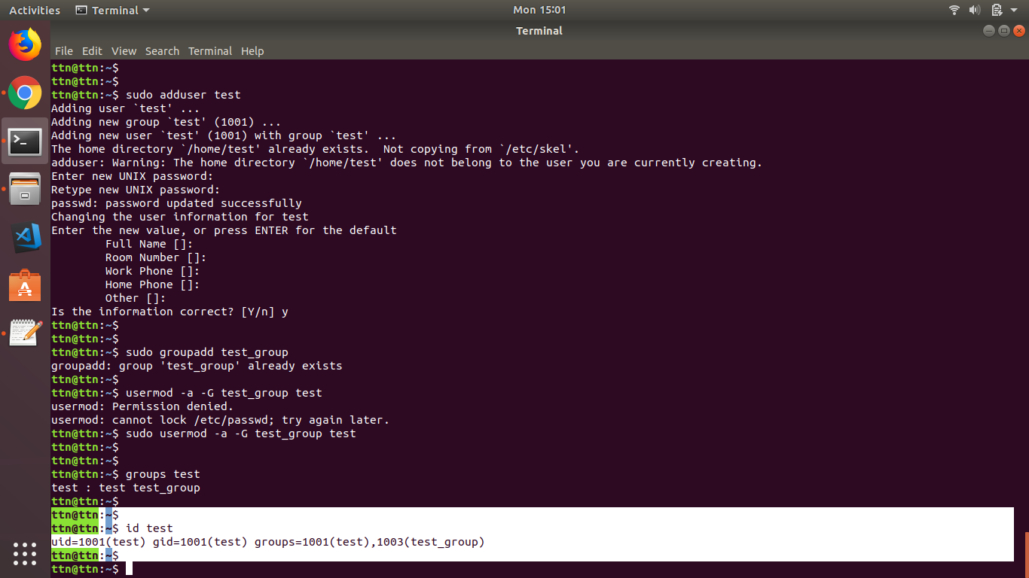

1. Lock this user.

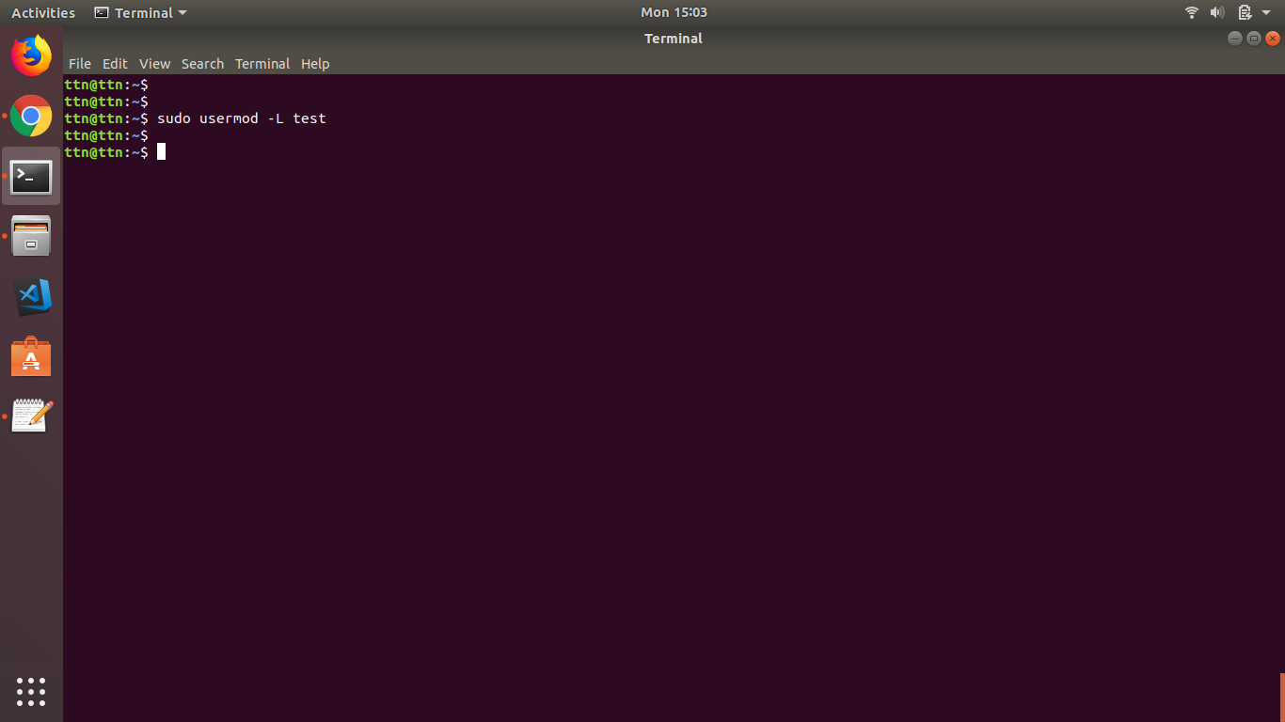

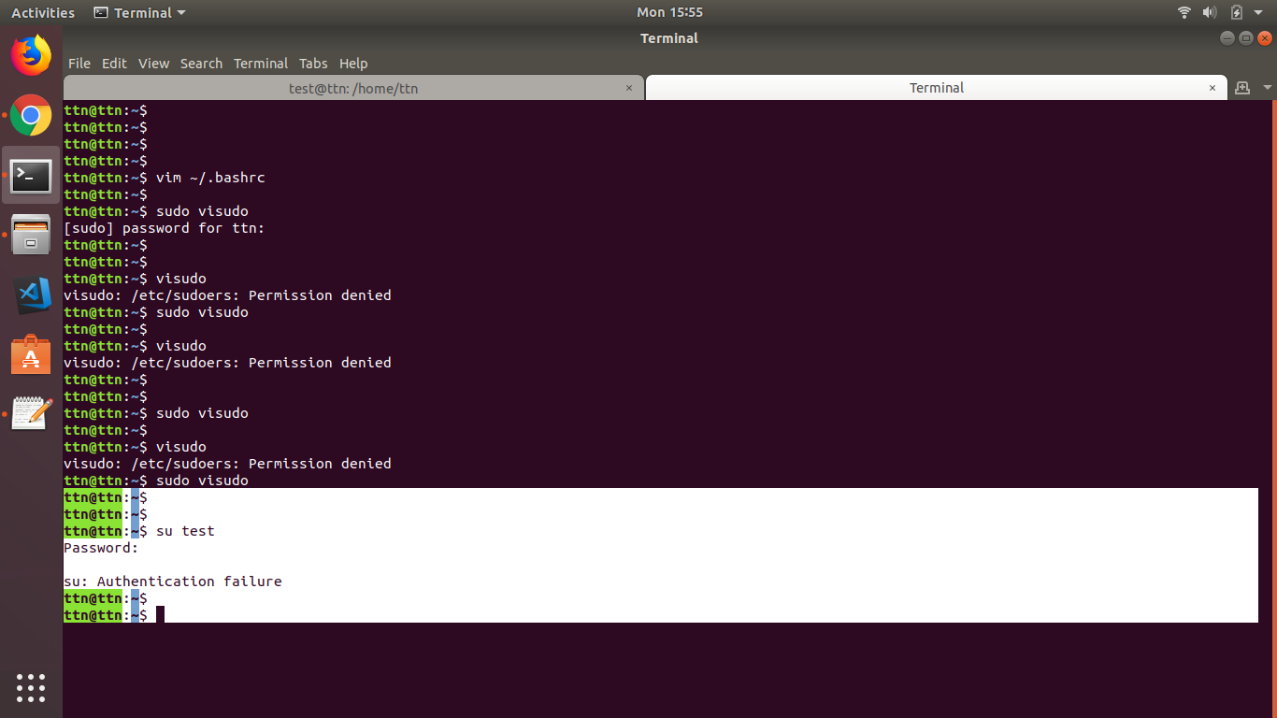

1. Give this user full access (without password).

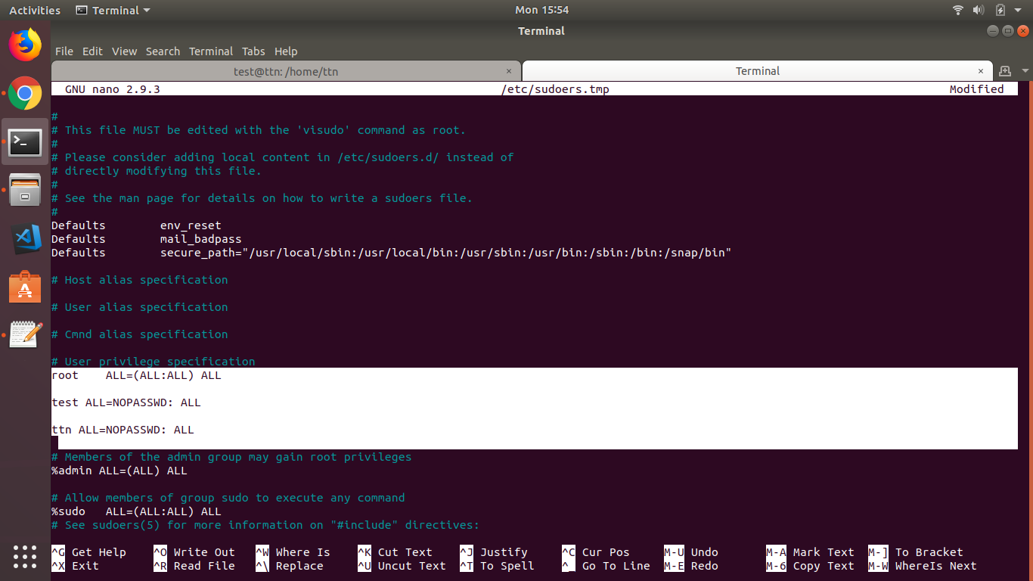

1. Delete the create user after taking backup of it home directory.

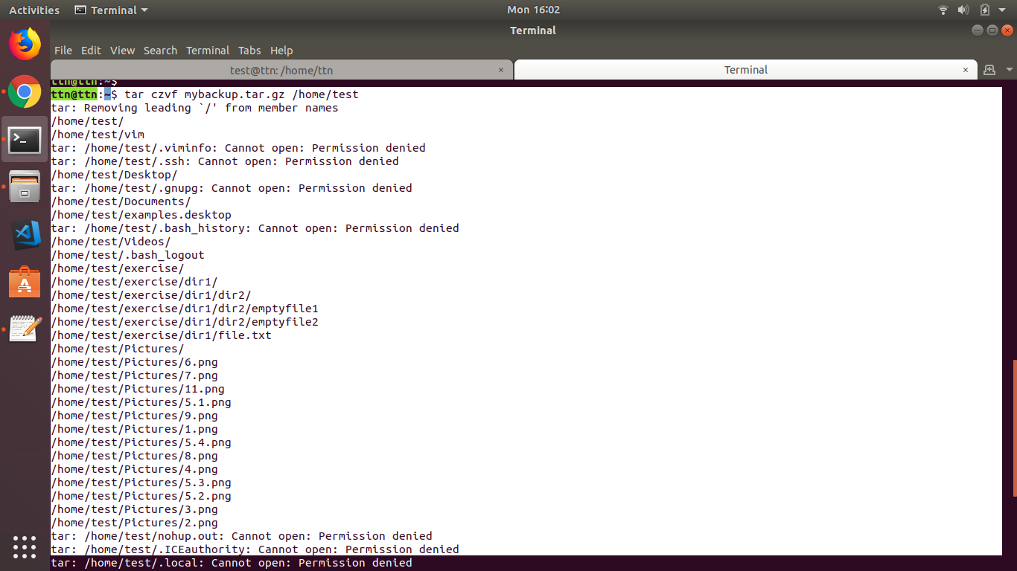

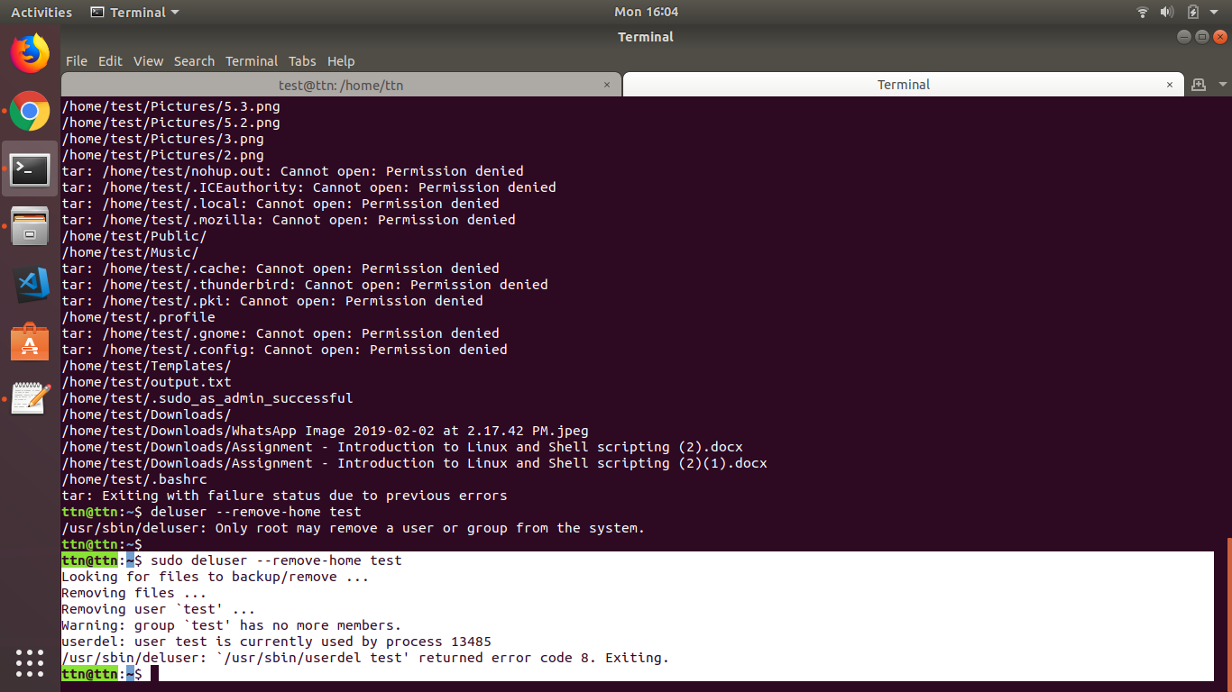

1. Create a file with some content. Change all lower case letter to upper case letter and save output to another file using redirections.

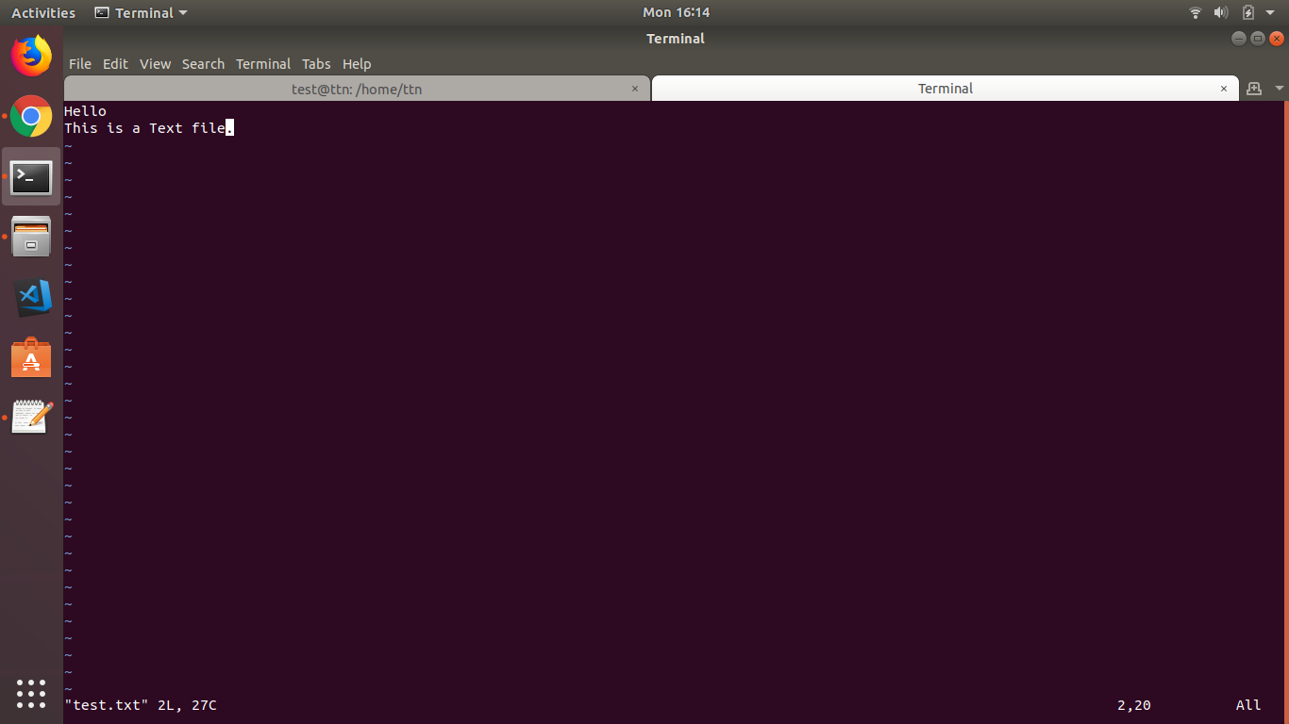

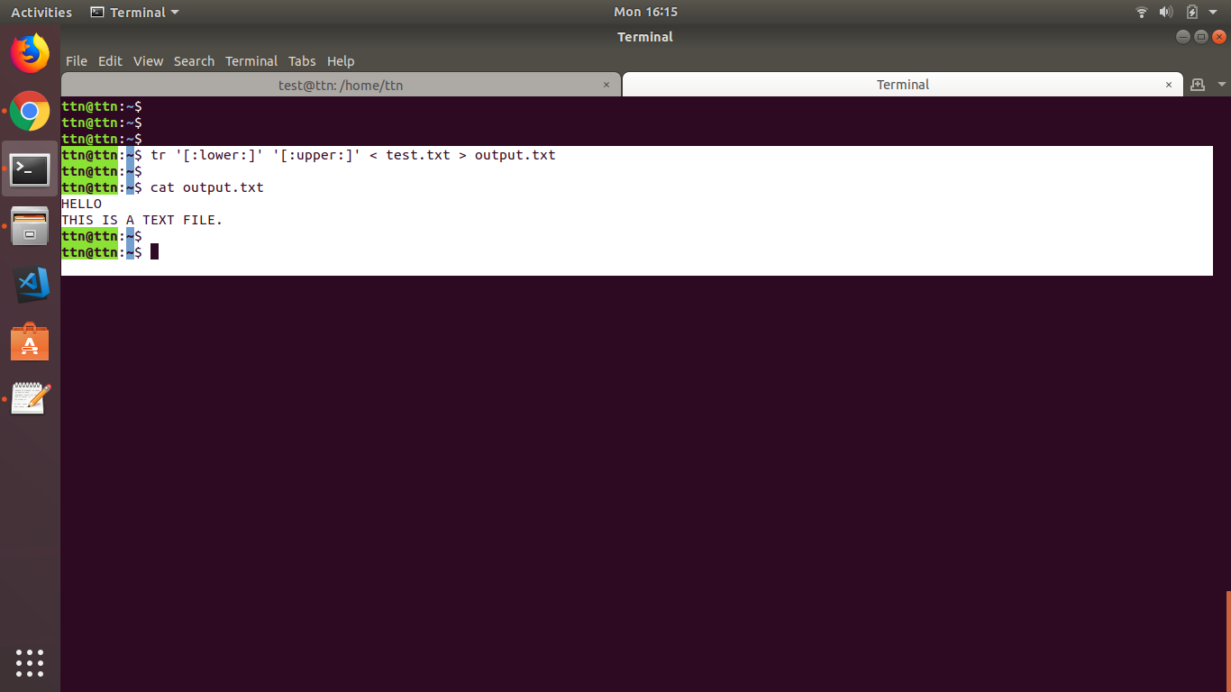

1. Set nice value of a process to -1.

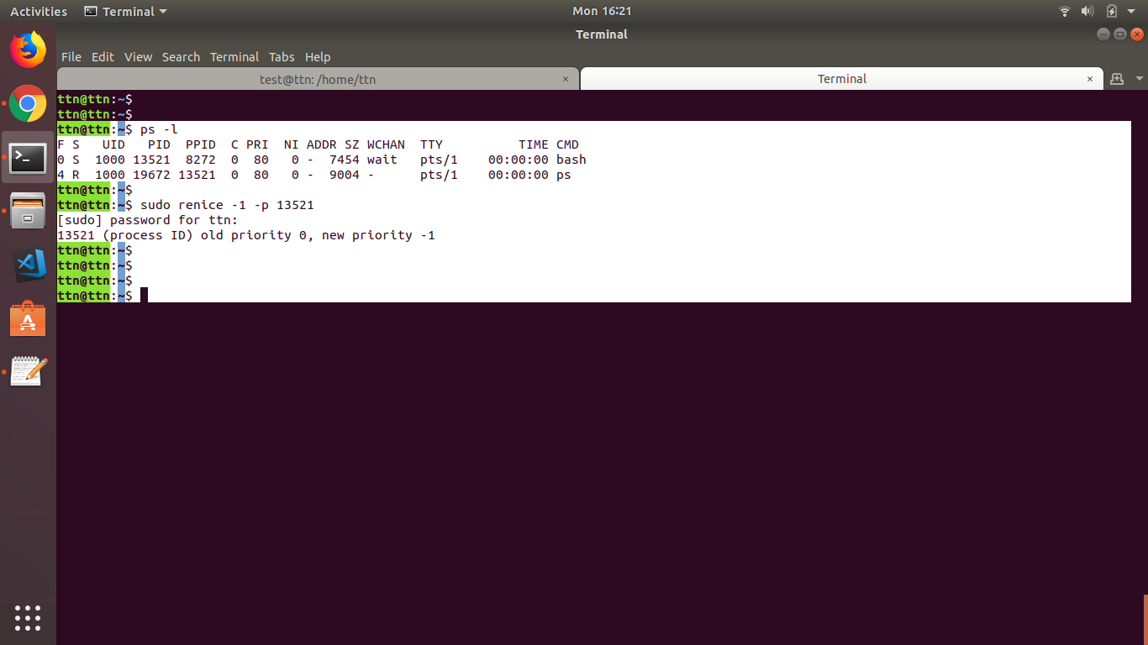

1. Get list of all files used by “telnet”.

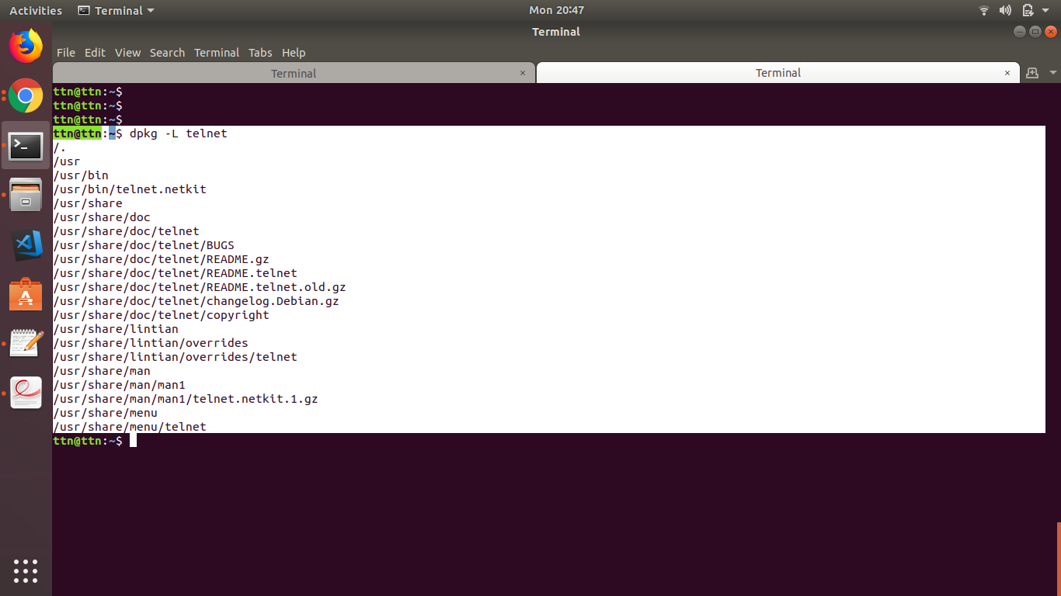

1. Check if port 22 is listening using netstat and telnet command.

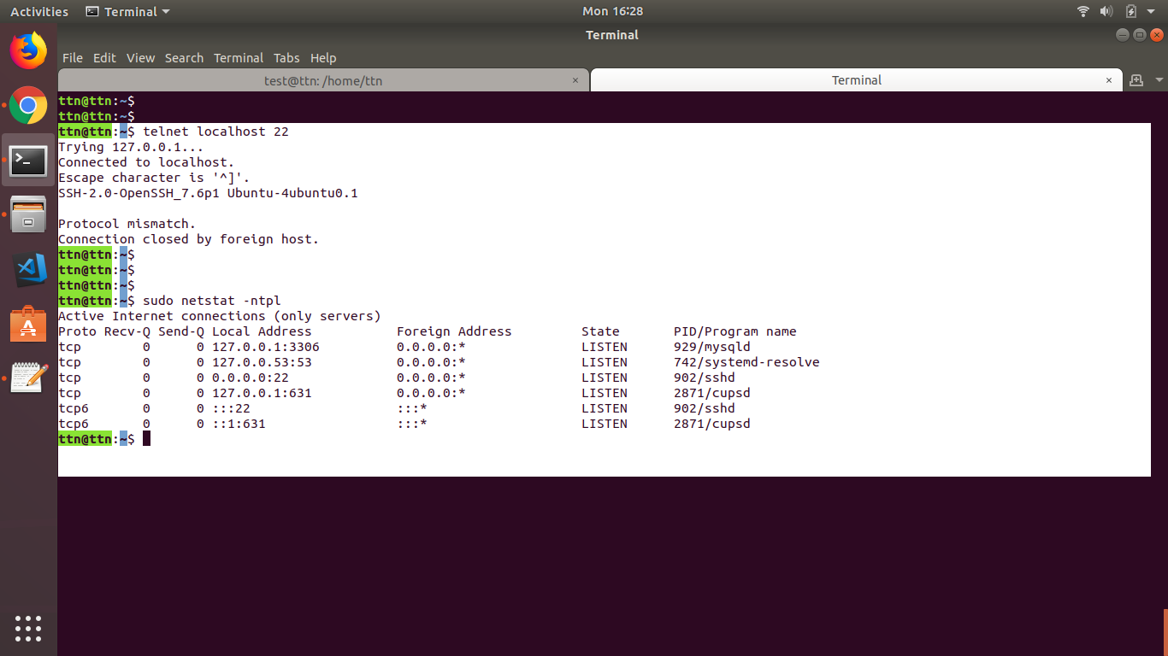

1. Create a cron job which runs once in a week at 23:45.

